**Lab 10**

**PROGRAM THAT CREATES A USER INTERFACE TO PERFORM INTEGER DIVISIONS**

* HANDWRITTEN PROGRAM

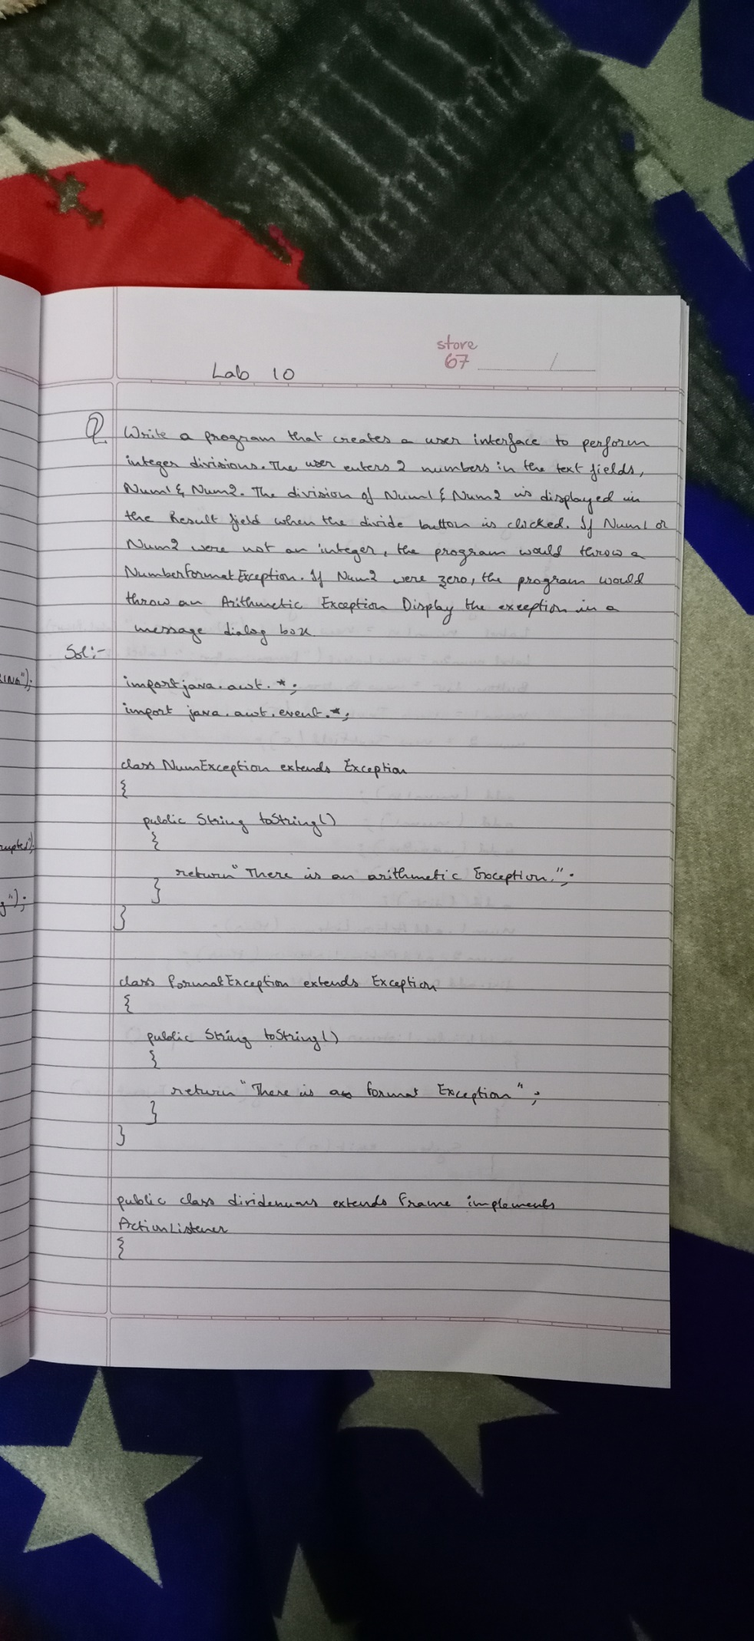

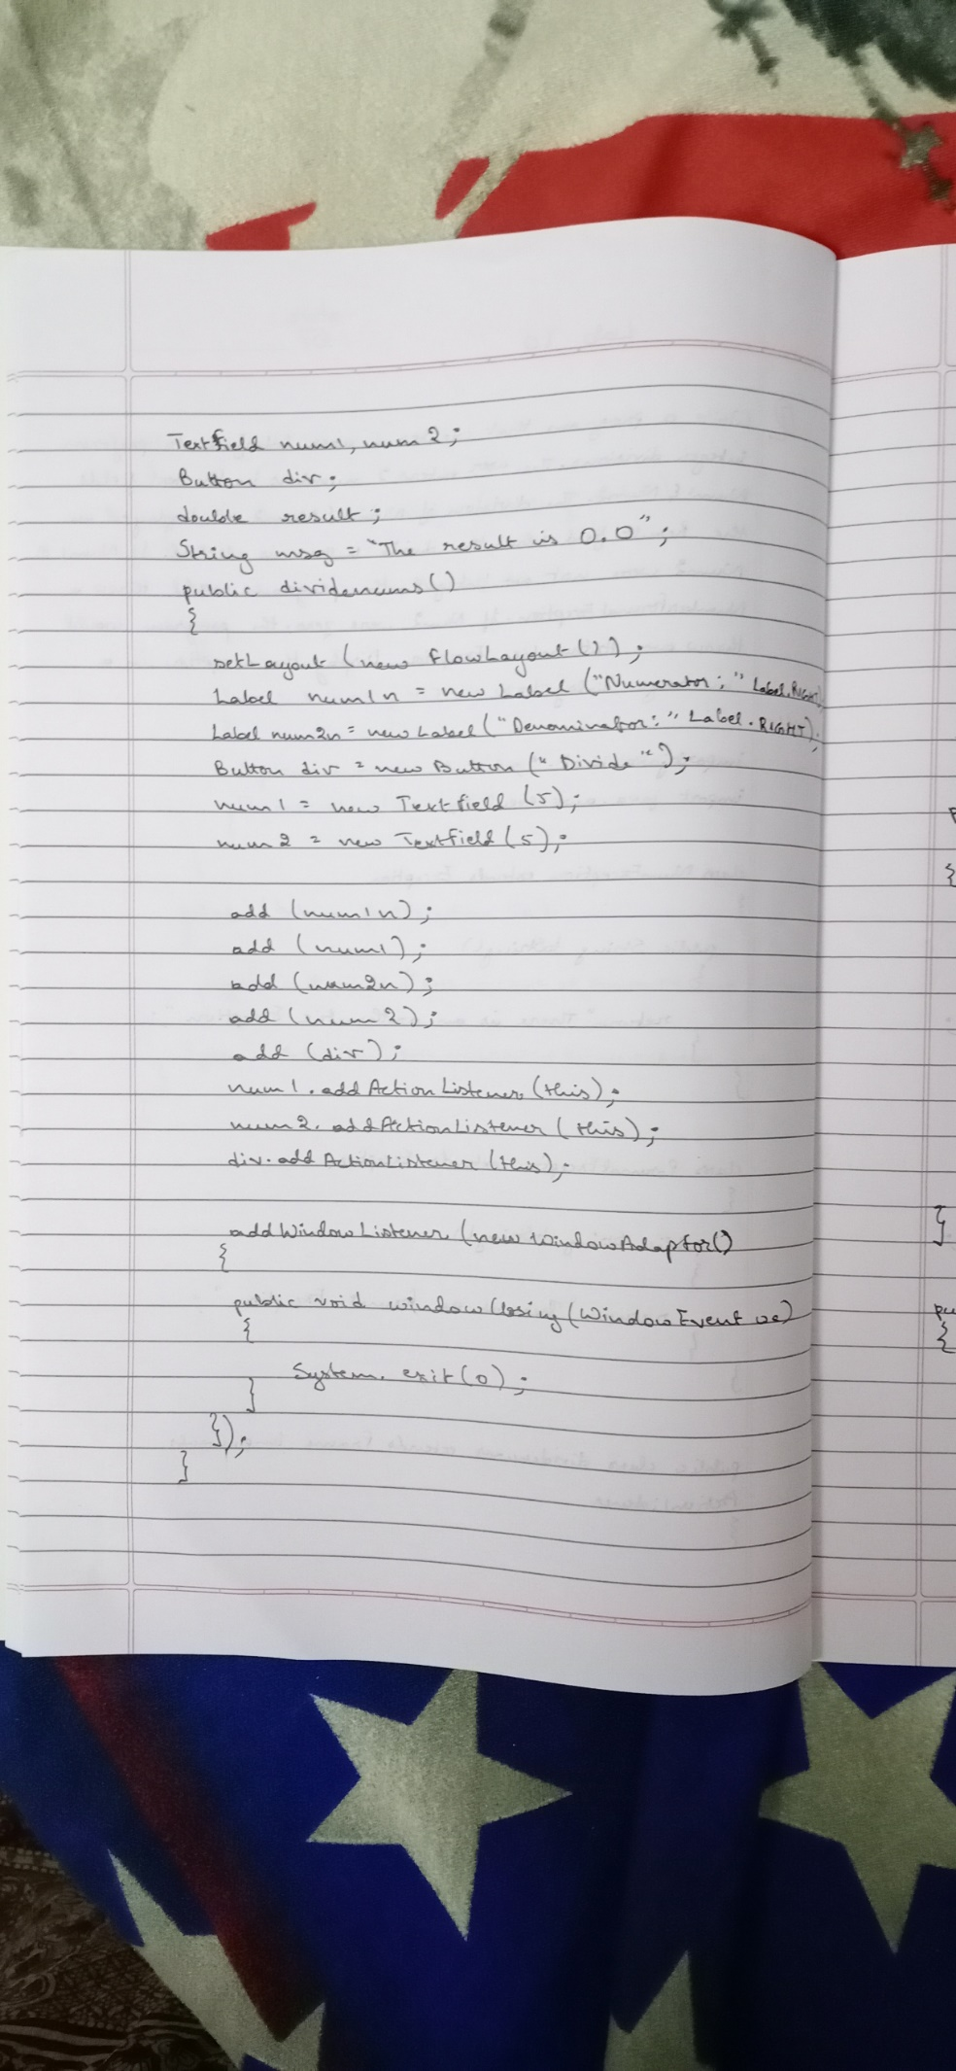

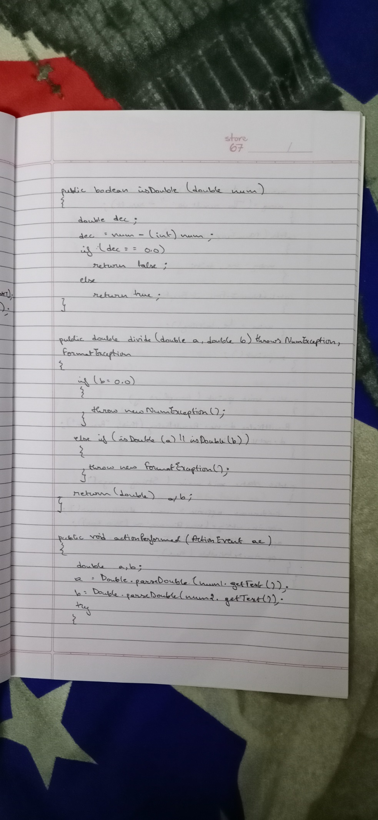

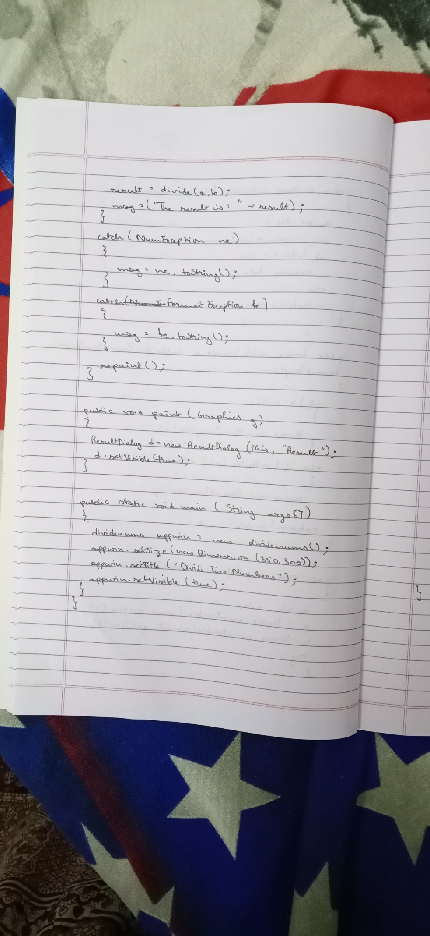

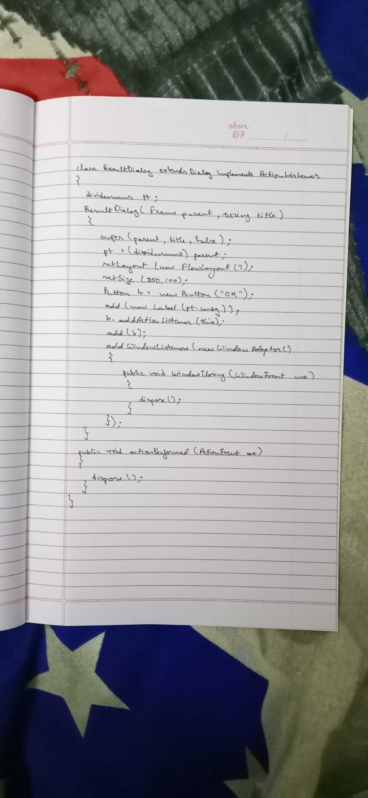

* PROGRAM

import java.awt.*;

import java.awt.event.*;

class NumException extends Exception

{

public String toString()

{

return "There is an Arithmetic Exception.";

}

}

class FormatException extends Exception

{

public String toString()

{

return "There is an Format Exception.";

}

}

public class dividenums extends Frame implements ActionListener

{

TextField num1,num2;

Button div;

double result;

String msg="The result is: 0.0";

public dividenums()

{

setLayout(new FlowLayout());

Label num1n= new Label("Numerator: ",Label.RIGHT);

Label num2n= new Label("Denominator: ",Label.RIGHT);

Button div= new Button("Divide");

num1=new TextField(5);

num2=new TextField(5);

add(num1n);

add(num1);

add(num2n);

add(num2);

add(div);

num1.addActionListener(this);

num2.addActionListener(this);

div.addActionListener(this);

addWindowListener(new WindowAdapter()

{

public void windowClosing(WindowEvent we)

{

System.exit(0);

}

});

}

public boolean isDouble(double num)

{

double dec;

dec=num-(int)num;

if(dec==0.0)

return false;

else

return true;

}

public double divide(double a, double b) throws NumException, FormatException

{

if(b==0.0)

{

throw new NumException();

}

else if(isDouble(a) || isDouble(b))

{

throw new FormatException();

}

return (double) a/b;

}

public void actionPerformed(ActionEvent ae)

{

double a,b;

a=Double.parseDouble(num1.getText());

b=Double.parseDouble(num2.getText());

try

{

result=divide(a,b);

msg=("The result is: "+result);

}

catch(NumException ne)

{

msg=ne.toString();

}

catch(FormatException fe)

{

msg=fe.toString();

}

repaint();

}

public void paint(Graphics g)

{

ResultDialog d=new ResultDialog(this, "Result");

d.setVisible(true);

}

public static void main(String args[])

{

dividenums appwin= new dividenums();

appwin.setSize(new Dimension(350,300));

appwin.setTitle("Divide Two Numbers");

appwin.setVisible(true);

}

}

class ResultDialog extends Dialog implements ActionListener

{

dividenums pt;

ResultDialog(Frame parent,String title)

{

super(parent,title,false);

pt=(dividenums)parent;

setLayout(new FlowLayout());

setSize(250,100);

Button b=new Button("OK");

add(new Label(pt.msg));

b.addActionListener(this);

add(b);

addWindowListener(new WindowAdapter()

{

public void windowClosing(WindowEvent we)

{

dispose();

}

});

}

public void actionPerformed(ActionEvent ae)

{

dispose();

}

}

* OUTPUT

